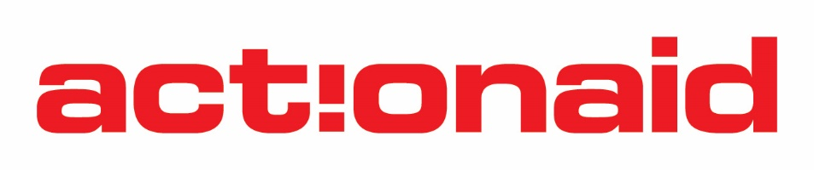
STANDARD GRANT-CONCEPT NOTE

Eligibility Criteria
- Concept Notes are accepted from the following types of Local organisations:
  - Network organisations
  - Individual organisations
  - Branches of a larger local organisation (with written consent from Head office)
The organisation must be:
  - Non-governmental
  - Non-international
  - Have a legal status and be registered in Zambia for over one year under the Societies Act, Companies Act, NGO Act or Land (Perpetual Succession) Act
  - Must be registered in Zambia for over 2 years with Audited financial statements including Management letters
  - Have a Constitution, Articles of Association or Trust Deed
  - Be a non-profit organisation
  - Have a bank account operated by more than one signatory
  - Be up to date with statutory Returns
  - Be accessible (traceable address, etc.)
  - Have an active Board for oversight

- GENERAL INFORMATION
1.1 Organisation’s contact details
Name of organisation
Physical address | (Plot number, road, area and town)
Name of contact person/position in the organisation
Telephone numbers | Office number |  | Cell phone
E-mail address
Website (if any)
1.2 Registration status of the organisation
Is your organization registered? | Yes |  | No
Under which Act is your organization registered?
Indicate the registration certificate number
Indicate the year of registration | [dd/mm/yyyy]
Is your organization non-profit and non-governmental | Yes |  | No
Does your organisation have a Constitution, Articles of Association, or Trust Deed? | Yes |  | No
Is your organisation a branch of a national organisation? | Yes |  | No
If yes, is your branch independent from the national office? | Yes |  | No
1.3 Statutory obligations and Financial Management systems
What is the financial year of the organisation | [mm/yyyy – mm/yyyy]
Do you have external Auditors? If yes indicate the name
Indicate when the last 2 external Audits were done | 1. | [mm/yyyy – mm/yyyy]
 | 2. | [mm/yyyy – mm/yyyy]
Is your organisation up to date with all statutory payments, i.e. NAPSA, PAYE, Annual returns? | Yes |  | No
Does your organisation use an accounting package? | Yes |  | No
What package?
Does your organisation have an accounting manual, financial rules and regulations, or similar? | Yes |  |  | No

1.4 Organisation ’Governance &Operations
Does your organisation have a Board? |  | Yes |  |  | No
How often is your Board supposed to meet annually?
Does the Board have sub-committees? |  | Yes |  |  | No
State the positions of Board members including their gender
Position in the organisation | Male |  | Female
1.
2.
3.
4.
5.
6.
1.5 Staffing
State the full-time staff the you have in the organisation including their positions
Position in the organisation | Male | Female | Filled/Not filled
1.
2.
3.
4.
5.
6.

- PROPOSED PROJECT
Title of proposed project
Proposed Amount for the Project
Project overall goal / impact
Thematic focus area aligned to SIDA
Project Objectives: | 1.  2.  3.
Project Key areas of impact and outcome | 1.  2.  3.  4.
Project key activities | 1.  2.  3.  4.
What will be the geographical coverage area of the proposed Project? | Province/s | District/s

2.1 What advocacy issues will your project focus on?
Include problem statement and justification-[Maximum 200 words]

2.2 How will your project be implemented using the HRBA
Explain how the proposed project will impact/involve the people living in poverty and marginalized in urban and rural areas using the Human Rights Based Approach (HRBA) Pillars: Campaigning, Empowerment, Solidarity and Demonstrating Alternatives –[Maximum 200 words]
E.g Empowerment – How will the project empower the people living in poverty and marginalized e.g what tools will be used

- CAPACITY AND TRACK RECORD
List the typical projects/activities you have undertaken in the last two years that demonstrate your organisation’s experience in advocacy work and what it has been able to achieve.]
3.1 Current activities
Project title
Contracts dates
Donor
Location of activities
Short summary including results | [maximum 100 words]

Title of activity
Start and end date
Source of funds
Location of activities
Short summary including results | [maximum 100 words]

3.2. Past activities
Name of donor
Contract period (Start/End date)
Project Name
Amount received
Location of implementation
Short summary including results | [Maximum 100 words]

Name of donor
Contract period (Start/End date)
Project Name
Amount received
Location of implementation
Short summary including results | [Maximum 100 words]

- GENDER AND YOUTH MAINSTREAMING
Demonstrate how your project will show commitment to gender and youth participation-[Maximum 200 words]

- TARGET BENEFICIARIES
List the Project’s target beneficiaries – [Maximum 60 words]

Documentation checklist
[Please ensure that you have provided the following documents as an attachment to your concept note and tick below.]
Please ensure you submit the documents listed below
List of required supporting documents |  | Documents provided
 |  | Yes | No
1. | Copy of the registration certificate
2. | Copy of the Constitution, Articles of Association, or Trust Deed
3. | Annual narrative / activity reports from previous year(s) and / or any other reports that demonstrate the organisation’s relevant track record
4 | Audited Financial statements including the Management letter (Where applicable)

I declare that the information given above in this concept note is true
Signature and official stamp
Position
Date

