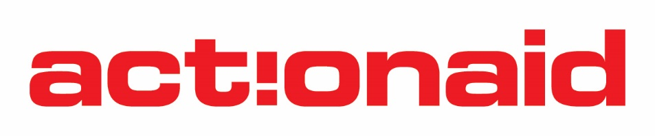
SOCIAL MOVEMENT GRANT- CONCEPT NOTE

Eligibility Criteria
Self-motivated Individuals/ Groups with the desire for advocacy, campaigning in the context of emerging social economic and political issues

- GENERAL INFORMATION
1.1 Organisation’s contact details
Name of organisation
Name of contact person/position in the organisation
Telephone numbers
E-mail address

1.2 Financial Management systems
Indicate how you have managed finances for similar activities in the past

- PROPOSED PROJECT
Title of proposed project
Proposed Amount for the Project
Project overall goal / impact
Thematic focus area aligned to SIDA
Project Objectives: | 1.  2.  3.
Project Key areas of impact and outcome | 1.  2.  3.  4.
Project key activities | 1.  2.  3.  4.
What will be the geographical coverage area of the proposed Project? | Province/s | District/s

2.1 What advocacy issues will your project focus on?
Include problem statement and justification-[Maximum 200 words]

2.2 How will your project be implemented using the HRBA
Explain how the proposed project will impact/involve the people living in poverty and marginalized in urban and rural areas using the Human Rights Based Approach (HRBA) Pillars: Campaigning, Empowerment, Solidarity and Demonstrating Alternatives –[Maximum 200 words]
E.g Empowerment – How will the project empower the people living in poverty and marginalized e.g what tools will be used

- TRACK RECORD
List the typical projects/activities you have undertaken in the past that demonstrate your organisation’s experience in undertaking similar activities
3.1 Past track record
What advocacy/campaign activities have you done before
Were these activities donor funded | Yes | No
If your activities were not donor funded how did you fund these activities
If your activities were donor funded Name the donor
Contract period (Start/End date)
Project Name
Amount received
Location of implementation
Short summary including results | (Maximum 100 words)

- GENDER AND YOUTH MAINSTREAMING
Demonstrate how your project will show commitment to gender and youth participation-[Maximum 200 words]

I declare that the information given above in this concept note is true
Signature
Position
Date

